APPENDIX 3

ANTHROPOLOGICAL TYPES

The American type
The Arctic type
The Atlanto-Baltic type
The Bushman type
The Far East type
The Indo-Mediterranean type
The Negro type
The North Asian type
The Central European type
The South Asian type
The South Siberian type
The Balkan Caucasian type

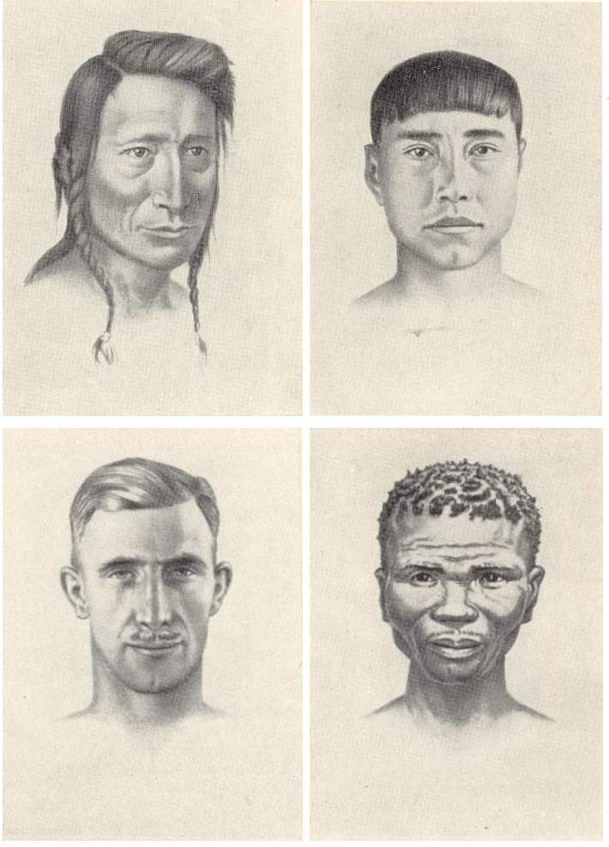
The American type
The Arctic type

The Atlanto-Baltic type
The Bushman type

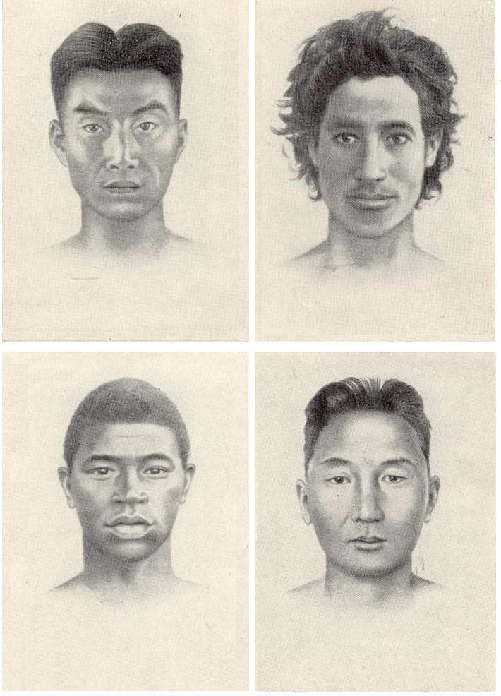
The Far East type
The Indo-Mediterranean type

The Negro type
The North Asian type

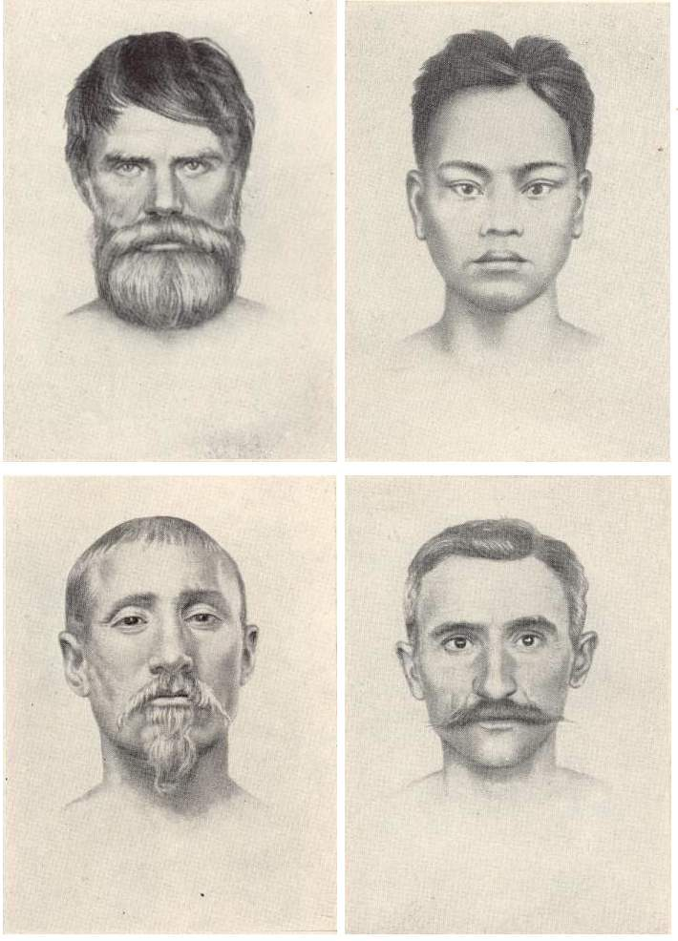
The Central European type
The South Asian type

The South Siberian type
The Balkan Caucasian type

