Certificate of Attendance
This is certify that
1st name Surname
participated in:
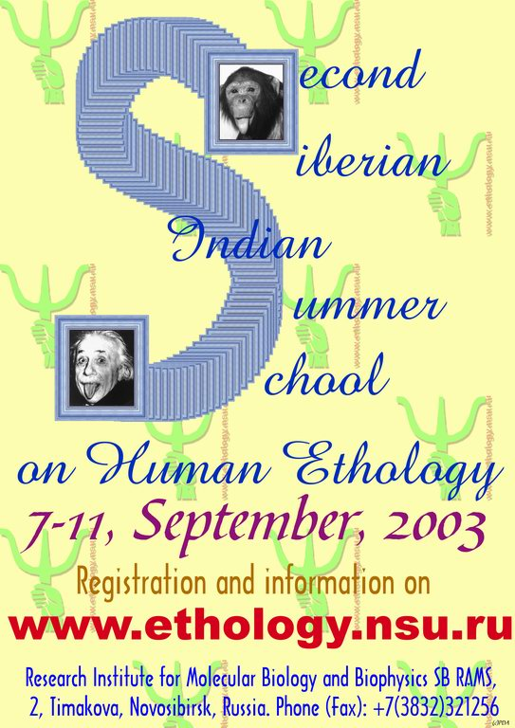

From International Organizers: Frank K. Salter, PhD

From Local Organizers: Arcady A. Putilov, PhD

